Inventory Analysis

Objective
The objective of this submission is to analyze inventory data stored in the ShopEaseDB database using SQL queries.
The analysis helps identify available products, out-of-stock products, highest-stocked products, and the average inventory quantity.
Total Products Available
This query identifies the number of products that currently have available stock.
SELECT COUNT(DISTINCT Product_ID) AS Total_Products
FROM Inventory
WHERE Quantity > 0;
Result:
The total number of products with available stock was successfully calculated.
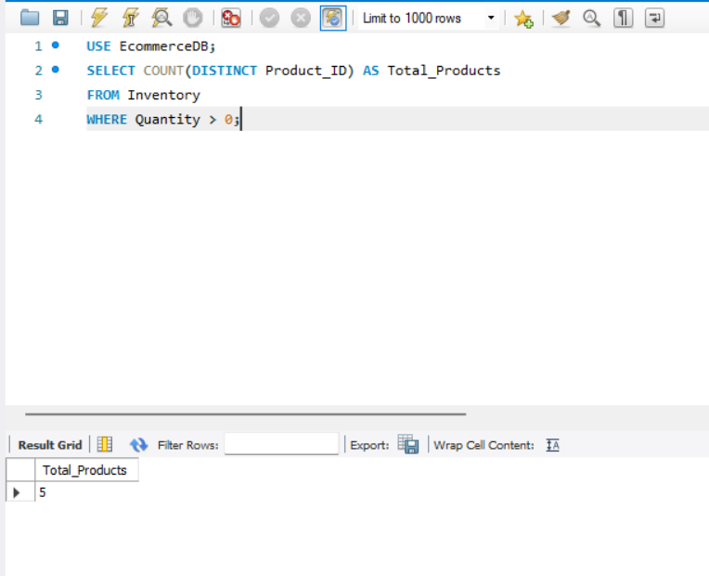
Products Out of Stock
This query identifies products whose total inventory quantity is zero.
SELECT p.Product_ID, p.Product_Name
FROM Product p
JOIN Inventory i ON p.Product_ID = i.Product_ID
GROUP BY p.Product_ID, p.Product_Name
HAVING SUM(i.Quantity) = 0;
Result:
The out-of-stock products were successfully identified.
Result:
Products with zero inventory were successfully identified.
Highest Stocked Products
This query displays products according to their total available stock in descending order.
SELECT p.Product_Name, SUM(i.Quantity) AS Total_Stock
FROM Product p
JOIN Inventory i ON p.Product_ID = i.Product_ID
GROUP BY p.Product_ID, p.Product_Name
ORDER BY Total_Stock DESC;
Result:
The products with the highest stock quantities were successfully identified.
Result:
The products with the highest stock quantities were successfully identified.

Average Inventory Quantity
This query calculates the average quantity of products available in the inventory.
This query calculates the average quantity available across inventory records.
FROM Inventory;
Result:
The average inventory quantity was successfully calculated.
Result:
The average inventory quantity was successfully calculated.
Final Result
The inventory analysis provided useful information about stock availability, out-of-stock products, highest-stocked products, and average quantity.
ShopEase inventory analysis completed successfully.

